Clinical Reasoning - BN603002 Senior Person’s Health

You are required to select ONE focused assessment tool that is relevant to a Senior in your care. A focused assessment provides you with detailed information about ONE specific aspect of health. Examples of focused assessments include falls risk assessments, continence assessments, pressure injury risk assessments or delirium scoring.

In collaboration with your Preceptor, select ONE resident in your care and perform a focused assessment (verbal consent will be required). The steps of the Clinical Reasoning Cycle (CRC) will guide your assessment and plan for the resident.

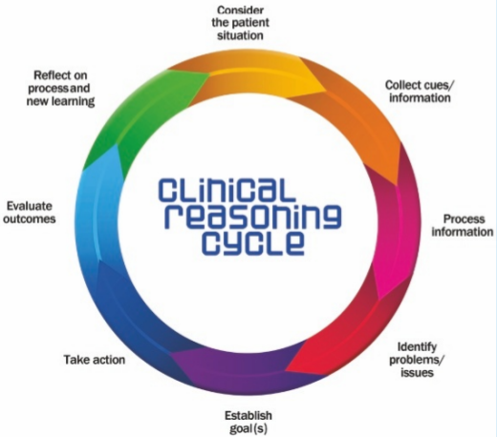

Levett-Jones, T., Hoffman, K., Dempsey, Y., Jeong, J., Noble, D., Norton, C., Roche, J., & Hickey, N. (2010). The five rights of clinical reasoning: An educational model to enhance nursing students’ ability to identify and manage clinically ‘at risk’ patients. Nurse Education Today, 30(6), 515–520. https://doi.org/10.1016/j.nedt.2009.10.020

Consider the patient situation
Briefly describe WHY this assessment is relevant for this resident currently.
What is the resident’s health history? (including basic pathophysiology).
What is their current functional ability (mobility, self-care etc) and why are they living in aged residential care? What are their routine prescribed medications?

Collect cues / information
Upload / attach the assessment here (ensure client & facility anonymity). This may be a scanned upload of the assessment or a ‘screenshot of a digital assessment’.

Process information
This is a critical stage, at the core of clinical reasoning. Carefully review your assessment findings. Where there are problems, consider these in light of any disease processes and medications that relate to this resident. Outline any further information or additional tests that you think might be useful now.

Identify problems / issues
Formulate TWO nursing diagnoses that are relevant to this resident, based upon your assessment. These may be actual or potential problems / issues.

Diagnosis 1.

Diagnosis 2.

Establish goals

Formulate ONE goal for each of the two nursing diagnoses above. A goal is what you want to happen for the problem that you identified. Each goal must relate to the resident that you have assessed.
Goal 1.

Goal 2.

Take action
State TWO nursing interventions for each of the two goals. These are the actual nursing cares that you will implement to achieve the goals in the short term (e.g. administer prescribed laxatives; assist to mobilise with a high frame etc). Consider whether or not these goals are acceptable to the resident. You will also need to support your choice of interventions with clinical guidelines / literature (e.g. Jarvis’s Health Assessment and Physical Examination or Lippincott Advisor). Be prepared to discuss these with your Clinical Lecturer.
Interventions for Goal 1 –

1.

2.

Interventions for Goal 2 -

1.

2.

Evaluate outcomes
How will you know that your interventions have been effective and the situation has improved? What other members of the healthcare team may be involved in this evaluation? (e.g. if it is a mobility goal then the physio may be involved)

Reflect on process and new learning
What have you learned about the focused assessment – are there any areas for further learning? How useful has the clinical reasoning cycle been in guiding you as you plan care?

Version 2, Dec 2024

