

BN604002 Y2 Mental Health and Addictions

Nursing Practice Care Plan

Name (pseudonym): Age:

Date of admission / presentation: Date care plan commenced:

Legal Status (Voluntary or relevant Law or Act):

Risk management plan: Yes No
(Only used in Dunedin MH Services, Te Whatu Ora)

Ethnicity:
First language preference:
Pronoun preference:
Vision/hearing impairment:
Alternate form of communication:

Client’s reason(s) for admission/presentation:
(What does client say?)

Client’s expectations of admission:

Brief Interdisciplinary team expectations/care plan:

Previous relevant hospital admissions:

Assessment using Te Whare Tapa Whā, (Durie, 1994):

Complete the brief assessment below:

A. Taha Tinana (physical health)

Heart rate:
Blood pressure:
Temperature:
Respiration (rate, pattern):

Body system/s (2) most impaired assessed:

Common and long term/chronic conditions:
(Consider metabolic syndrome, diabetes, cardiovascular and respiratory disease, mental health related physical conditions).

Pain/discomfort:
(Consider both physical and psychological, past, and now).

B. Taha wairua (spiritual health)
(Brief assessment).

Valuing: (sense of purpose, meaning, inner strength, capacity for change, self-acceptance)

Strengths and coping skills: (personal strengths and resources)

Cultural/spiritual attitudes/beliefs & values:

C. Taha whānau (family health)
(Brief assessment).

Early development: (Birth, Plunket books for early development history, Milestones, Education history, literacy & numeracy).

Whanau/Family background: (Whanau/family & iwi/whakapapa/significant stories including physical/medical history, mental health history, important stories, genogram/whanau family tree).

Social relationships: (employment, whanau, children, parents, partners, sports/interest groups).

- Taha hinengaro (mental health) The capacity to communicate, to think and to feel mind and body are inseparable (comprehensive mental state & risk/safety assessment)

Appearance:
(Consider age & stage and weather & environs)

Behaviour/Motor activity:
(Pacing, agitated, slowed, catatonic)

Speech and Thought Processes: (volume, rate, quantity, quality)

Thought Content:
(What the person is thinking, ruminations, obsessions, compulsion, homicidal/suicidal thoughts, delusions. Start to consider risk).

Perceptions: (auditory, visual, tactile, olfactory hallucinations, illusions, depersonalisation, derealisation)

Mood: (Subjective: How the person says they feel. Consider sleeping patterns: (insomnia, quality, sleep aids), diet, hobbies and sport, ADL’s, level of motivation).

Affect: (Objective: How you think they look? Congruent/Incongruent mood & affect. Is affect blunted, flat, restricted, labile).

CNS: (Head injuries, knocked out, concussion, neurological changes &/or symptoms)

Orientation: (Can individual explain: Person, Place, Time).

Memory: (intact, short term, long term, provide examples).

Judgement: (intact, age appropriate, impaired).

Insight: (Do they understand or believe they are unwell?

Alcohol and other drugs:

Brief intervention, assessment tool about the use of psychoactive substance use in the last 3 MONTHS.

Use the ASSIST Lite: Alcohol, Smoking and Substance Involvement Screening Test
For Tobacco, Alcohol, Cannabis, Amphetamine-type stimulants, non-prescribed & prescribed sedatives, sleeping tablets, opioid (street & prescribed) and any other psychoactive substances.

If moderate/high use in last 3 months &/or longer then discuss with RN Preceptor re further referrals to AOD treatment and support.

https://assistportal.com.au/resources/

Gambling: Yes No

Historical &/or current? Referral?

RISK: (Can include risk of suicide, accidental and intentional overdose of alcohol and other drugs, financial, emotional, and sexual exploitation, vulnerability from others).

Using the Columbia Suicide Severity Rating Scale (C-SSRS) assess the risk of the person you are caring for.
Include:

- Strengths/Protective Factors.
- Long term (Static/Past/Historical) risk factors including,
  - suicidal behaviour,
  - impulsivity (arson, self-control issues, poor emotional regulation, and coping skills) Alcohol & other drugs abuse or dependency.
- Recent/dynamic/present suicidal ideation/plan and its lethality.
- Recent self-harm and suicidal behaviour.
- Recent changes in symptoms and illness state.
- Ability to have insight into illness, distress, impairment of judgement.

Harm to Self: Self harm, Isolation, Alcohol and drug abuse/dependency, command or degradatory hallucinations, Exploitation from others, financially, sexually, socially impulsive & paranoid delusions (false fixed beliefs) that leave individuals at risk.

Harm to others: Family violence, Alcohol, and drug abuse/dependency, command or degradatory hallucinations instructing violence, risk taking involving others. Exploitation from others, financially, sexually, socially impulsive & paranoid delusions (false fixed beliefs) that leave individuals at risk.

Clinical Reasoning

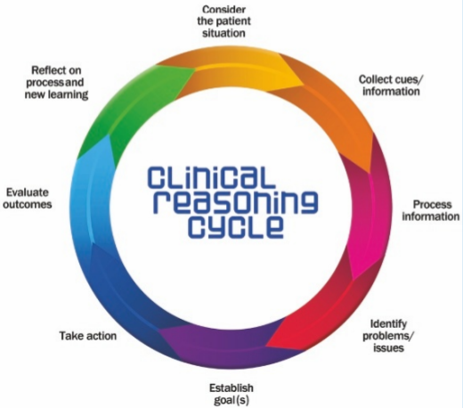

Source: Levett-Jones, T, Hoffman, K, Dempsey, Y, Jeong, S, Noble, D, Norton, C, Roche, J and Hickey, N (2010). The ‘five rights’ of
Clinical reasoning: An educational model to enhance nursing students’ ability to identify and manage clinically ‘at risk’.
Patients. Nurse Education Today. 30(6): 515-20.

In this section you will need to process the information you have collected from your assessment using the Clinical Reasoning Cycle, (Levett-Jones, 2018):

Identify ONE safety/risk /issue and establish goal: (from the formulation above clearly identify one with
interventions, rationale, and evaluation of the chosen approach to care)

- Nursing Issue
- Goal
- Interventions or Plan
- Rationale/Why?
- Evaluation: (what worked well, what didn’t work well, what would you change?)

Linking Theory to Practice (using appropriate literature, reference, and research the following to show the process of linking theory to practice with your chosen client)

Provide the following information in relation to your client.
Include:
A brief overview of diagnosis, (referenced) and how this relates to your client.

Psychiatric medications include the following and how they relate to your client:
mechanism of action, indications for use side effects, contraindications, client education.

References:
Durie, M 1994, Whaiora: Māori health development, 2nd edn, Oxford University Press New Zealand: Oxford, UK.

Levett-Jones, T 2018, Clinical reasoning: learning to think like a nurse: 2nd edn, Pearson Australia: Melbourne, Australia.

University of Columbia. 2009. Columbia-Suicide Severity Rating Scale (C-SSRS).

University of Adelaide. 2023. ASSIST Lite: Alcohol, Smoking and Substance Involvement Screening Test.

