(Download to use)
Programme / Course
(Record programme / course name here)
Academic Leader Name
Health safety and wellbeing is everybody’s business
Academic Leader  Sign off |  | Date

Risk types
CRITICAL RISKS
Those risks that cause fatalities or permanent life changing injuries
COMMON / GENERIC RISKS
Those risks that are common / generic in all areas while working on or walking in and around a site
SPECIFIC RISKS
Those risks that are specific to the area

How are risks managed?
Risks are managed by assessing whether the risk can be eliminated.
If unable to be eliminated, use the hierarchy of control for each individual hazard to identify and assess the level of risk prior to controls.
Controls are put in place to minimise the risk by taking reasonably practicable steps, aiming to have a low residual risk.
Some risks may naturally remain at a level that cannot be reduced any further.
INTRINSIC RISK (prior to controls)
Is the level of risk with no physical controls in place
RESIDUAL RISK (after controls in place)
Is the risk after the controls are in place
RISK APPLICATION
RED – must cease work immediately. Additional controls must be put in place to further manage the risk and be continually monitored.
YELLOW or ORANGE – work can continue with the application of the controls in place and continually monitored.

CRITICAL RISKS (CR)
(delete the critical risks that do not affect your area)
CR Risk Profiles to be included in the Risk Assessment and Management
Arboriculture | Adventure Activities  - Avalanche  - Capsizing  - Rock Climbing  - Mountain Biking | Working at Height – Contractor / Maintenance Teams
Student Distress | Specialist Vehicles | Driving
Machinery and Equipment | Hazardous Substances | Food Safety
Construction Projects | Hot works (eg. Welding) | Blood and Body Fluids
COMMON / GENERIC RISKS
(delete the common / generic risks that do not affect your area)
Manual Handling | Computer Use | Driving and Vehicle Safety
Poor Communications | Gardens and Vegetation | External Paths, Walkways and Steps
Electrical Hazards | Emergency Response / Preparedness | Stress and Fatigue
Stairs | Harassment and Bullying Prevention | Ice in Winter
Ventilation and Heating | Lighting | Service Contractor Management
Smoking on Campus | Chemical Management | Kitchen Facilities
International Travel
SPECIFIC RISKS
Include risks specific to your area that have not been covered above

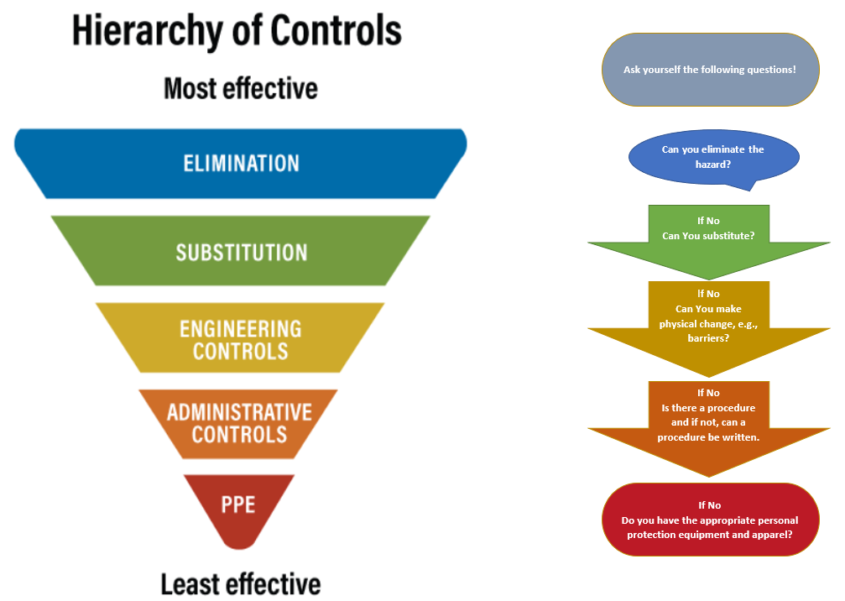

Risk Matrix

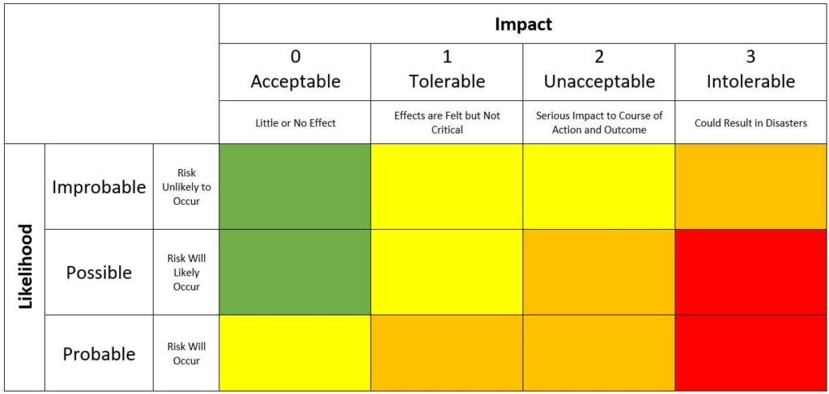

How to use the risk assessment matrix
- Identify the hazards and risks
- Determine controls using the “Hierarchy of Controls”
- Record the risks and their controls
- Assess and determine the risk criteria of each activity with controls in place
- likelihood of risk occurring (level of possibility)
- impact if risk occurred (how “big” an event could be)
- Prioritise the risks (green, yellow, amber, red), after the controls have been recorded

Personal Protective Equipment / Specific activity clothing
No-one is permitted to take part in the activity if the required clothing, equipment, and personal protective equipment (PPE) is not available at the time of taking part.

Hazard Description | Residual Risk Rating | Hierarchy of Control | What controls are you going to implement to manage the hazard and its associated risk/s
EXAMPLE  Manual Handling  Lifting and shifting heavy weights  Items stored too high or low  Awkward or unstable loads  Accessing stored items  Unsecured filing cabinets | Mitigate | Administrative controls | Storage:  - Commonly handled items are stored between knee and shoulder height  - Heavy items at floor level with adequate access  - Items on shelves are stored tidily– no overhanging items  - Shelving and Filing Cabinets are secured to wall  Carriage:  - Use Campus Services mail delivery service for heavy items  - Use lifting and carrying equipment where available e.g. trolleys, sack barrow  Personal Lifting Technique:  - Attend a Manual Handling Awareness Training every two years
(Other)
(Other)
(Other)
(Other)
(Other)
(Other)
(Other)
(Other)
(Other)
EXAMPLES OF HAZARDS – food (allergies, hygiene), communication, electrical, manual handling, trip hazards, ventilation, vehicle movements

