Student Gear List 2022
Item |  | Place to purchase | Cost | Necessity
Climbing Helmet  Climbing helmet  Must have chin strap and be rated for side impact  Bright colours only | 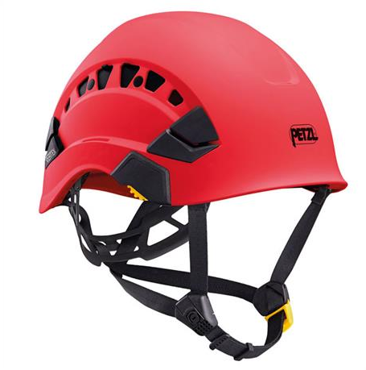 | Husqvarna  Levin Sawmakers  Metro Green  Treehub  Treetools | $149rrp | Compulsory
Ear muffs  Peltor X4P3  Or any grade 5 earmuffs that attach to helmet  *Ensure they will fit the model of helmet you have selected | 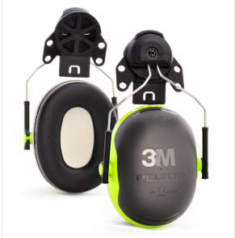 | Husqvarna  Levin Sawmakers  Metro Green  Treehub  Treetools | $80rrp | Compulsory
Visor  Solid visor that attaches to helmet.  *Ensure visor is correct fit for specific helmet models | 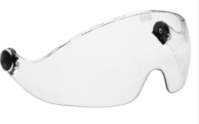 | Husqvarna  Levin Sawmakers  Metro Green  Treehub  Treetools | $87rrp | Recommended
Chainsaw trousers  Arborist specific pants are recommended for the stretch in the fabric and stitching. | 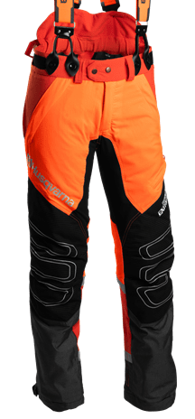 | Husqvarna  (Roslyn Mowers & Heating)  Metro Green  Levin Sawmakers  Treehub  Treetools | $210 - $500 | Compulsory
Climbing Line  Specifications  - 45meters minimum  - Diameter between 11.5mm-12mm  - Double braid construction  - Spliced eye at one end only | 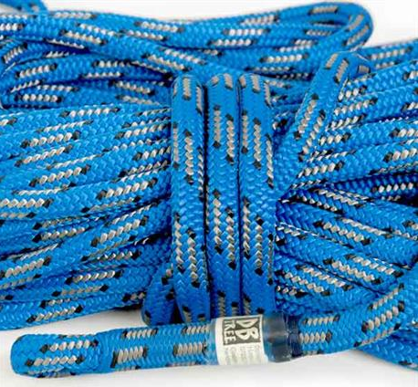 | Levin Sawmakers  Metro Green  Treehub  Treetools | $285 - $400 | Compulsory
Handsaw  Silky Gomtaro, Zubat or Tsurugi. 270mm minimum blade length. Medium size teeth | 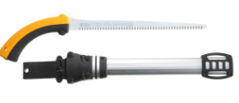 | Levin Sawmakers  Metro Green  Treehub  Treetools  Stihl Shop Dunedin or Milton | $86 - $140 | Compulsory
Carabiners  2x HMS/pear shaped Carabiners  Minimum strength 22kn  Approximate dimensions  Length 107 mm  Width 71 mm | 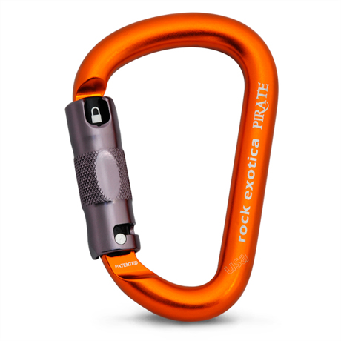 | Levin Sawmakers  Metro Green  Treehub  Treetools | Average $45.00each | Compulsory
Carabiners  4x oval shaped carabiners  Minimum strength 22kn  Approximate dimensions  Length 109 mm  Width 66 mm | 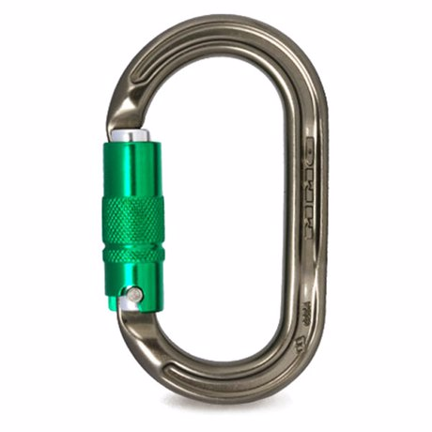 | Levin Sawmakers  Metro Green  Treehub  Treetools | Average $45.00each | Compulsory
Safety Boots  Steel cap, lace up with good ankle support  Chainsaw protection is highly recommended | 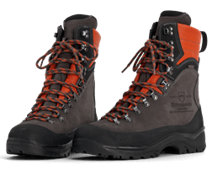 | Husqvarna  Levin Sawmakers  Metro Green  Treehub  Treetools  Any safety clothing supplier | $200 - $700 | Compulsory
Hi-vision clothing  Shirts, jersey, and jacket  Dunedin winters are cold. Make sure you have adequate clothing to keep warm | 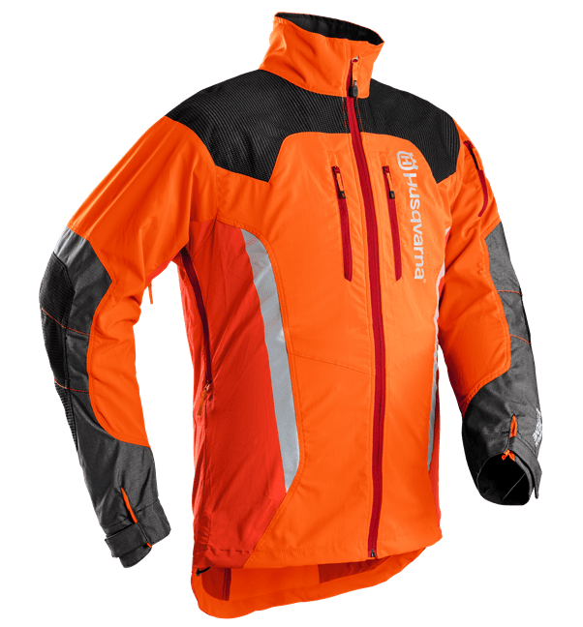 | Husqvarna  Metro Green  Levin Sawmakers  Traffic Management & Control  Treehub  Treetools  Or any safety clothing supplier | $50 - $300 | Compulsory
Safety glasses  Bolle Rush Plus Clear Lens Safety Spectacles | 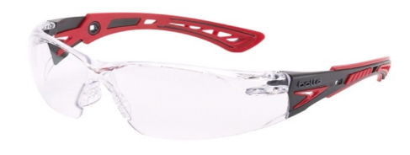 | NZ Safety Blackwoods or any Bolle supplier | $17rrp | Compulsory
Secateurs  Bypass style | 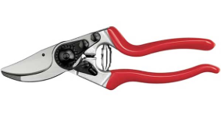 | Levin Sawmakers  Metro Green  Treehub  Treetools  Or any garden stores | $25.00 - $180.00 | Compulsory
Secateurs holster | 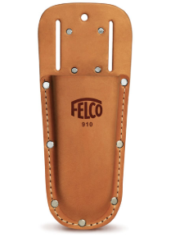 | Levin Sawmakers  Metro Green  Treehub  Treetools  Or any garden stores | $15 - $40 | Compulsory
Tree identification Book  Field Guide to New Zealand Native Trees. (Dawson, J & Lucas, R) | 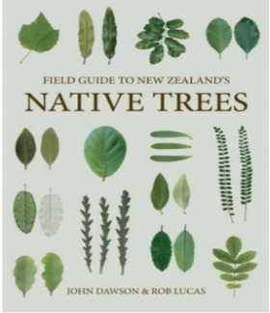 | University Bookshop | $45.00rrp | Recommended
Knot book  Knots at work A Field Guide for The Modern Arborist. (Jepson, J) | 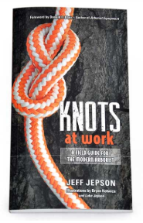 | Levin Sawmakers  Treetools | $39.90rrp | Highly Recommended

Please do not buy equipment until the programme begins

(All prices are approximate and subject to change)

Any questions about gear purchases please contact
Ben ben.fentiman@op.ac.nz 021 735 575

Recommended arborist suppliers that support Otago polytechnic and offer student discounts are:

Husqvarna www.husqvarna.com/nz/ Levin Sawmakers Ltd www.timbersaws.co.nz
MetroGreen www.metrogreen.co.nz NZ Safety Blackwoods https://nzsafetyblackwoods.co.nz/en/
Road Materials www.roadmaterials.co.nz/ Traffic Management and Control www.trafficmanagementltd.co.nz
Tree Hub www.treehub.co.nz Treetools www.treetools.co.nz

