hummingly ™
Hummingly is the creation of Elizabeth McNaughton and Jolie Wills,(Cognitive Scientist) a duo who have worked in disasters around the world for more than two decades. The realisation that helping one person, one community, one disaster at a time was no longer enough, lit the spark that became Hummingly. Elizabeth and Jolie set about creating easy to use products that people, communities, and workplaces the world over could access to do well in tough times.
These proven products are based on Elizabeth and Jolie’s knowledge gained in real disaster and crisis situations. They have gathered wisdom from over 100 crisis leaders, feedback from thousands of disaster survivors, scientific insights from their background in cognitive psychology and a shared passion to prepare the world to do disruption, stress and uncertainty well.

The Doing Well deck is for individuals, teams and organisations who want to deal to stress and disruption.
The deck of 100 cards are for you if you want to:
- prevent burnout and support others
- perform well under pressure
- make an effective wellbeing and resilience plan in 20 minutes.

The Doing Well cards were created on the back of decades of global experience working in disaster and disruption. The research behind the cards included interviews with over 100 crisis leaders from around the world.

Step 1: Open and Divide
The cards come in a pack of 100. Once opened they can easily be divided into 6 coloured sections. Each of these sections is designed to help you know what to focus on to get you through challenging times:

1. Connect
Mobilise and get the best support from your support network when you need it most.

2. Tips for Turbulence
Tips, tricks and tales from people around the world to help steer you through rough times.

3. Prototype Your Body
Small experiments to help you work out how best to support your body to perform and stay well, even under pressure.

4. Damn Good Decisions
When the pressure is on that we need our decision-making powers to be at their best. Making poor decisions only adds to our load and our stress levels. These cards provide a range of questions that you can use to test key decisions.

5. The Cool Down
These cards help guide you when you risk coming undone under pressure. It is during the calm that you are best placed to reflect on your tendencies and work out your strategies before high emotion and stress hit.

6. Your Next Move
A range of ways to use the cards both by yourself, in teams and at home.
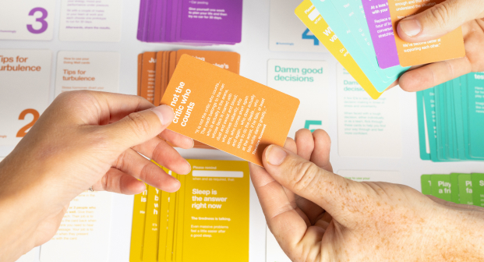

Step 2:
Choose your favourite cards
Choose your favourite cards from each section. Which cards will be most useful for you or your team when you are under pressure? Which cards resonate or jump out to you?

Step 3:
Build a wellbeing and resilience plan
Your chosen cards will form a wellbeing and resilience plan so you and your team are prepared when things get tough
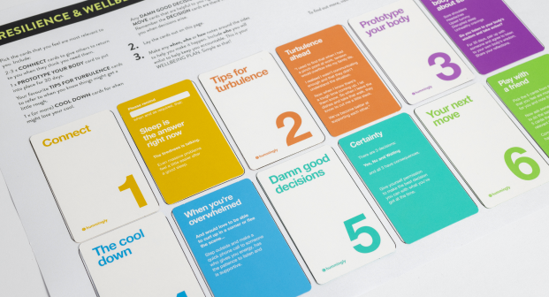

This just one of the many ways to use the Doing Well Deck.
The Activity Guide provides us with many more examples – or you can choose your own.
Doing Well Deck Activity Guide

