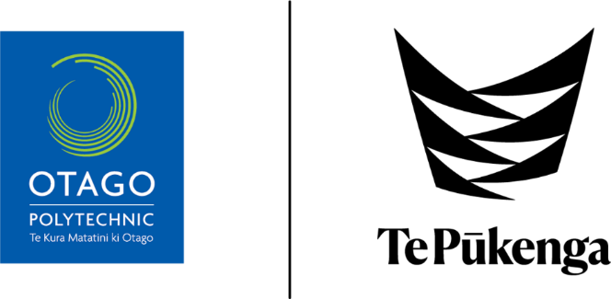

**Summative Preceptor Feedback Form**

**New Zealand Diploma for Enrolled Nursing Programme 2024**

**NURS4415**

**Ākonga name & ID number:**

**Preceptor name & NCNZ registration number:**

**Clinical placement location:**

**Dates of placement:**

**Guidelines for Preceptor**

**Constructive feedback** is an essential component of the learning process during placements as it assists students to identify areas of practice that are well performed and areas of practice that may require further development.

**Please ensure you discuss your feedback with the student, so they are aware of any areas that they need to address.**

|  |  |
| --- | --- |
| **NCNZ Competencies for Enrolled Nurses (2012)**  **Domain One: Professional Responsibility**  This domain contains learning outcomes that relate to professional, legal and ethical responsibilities and cultural safety. These include being able to demonstrate knowledge and judgement and being accountable for own actions and decisions while promoting an environment that maximises clients’ safety, independence, quality of life and health.   |  | | --- | | * Demonstrate professional behaviour at all times. * Apply safe, sustainable, legal and ethical practice. * Apply the principles of Te Tiriti o Waitangi to nursing practice. * Demonstrate culturally safe practice as determined by the health consumer. |   Comments:    **Have these been achieved?** *circle* **Yes / No** |
| **NCNZ Competencies for Enrolled Nurses (2012)** Domain Two: Provision of Nursing Care This domain contains learning outcomes related to patient assessment and managing client care which is responsive to client needs, and which is supported by nursing knowledge and evidence-based research.  |  | | --- | | * Contributes to assessment, planning, implementation, and evaluation of nursing care. * Demonstrate clear, concise, timely and accurate documentation. * Recognise and report changes in health status to appropriate health professional. * Contributes appropriate health education to the health consumer. |   Comments:  **Have these been achieved?** *circle* **Yes / No** |
| **NCNZ Competencies for Enrolled Nurses (2012)**  **Domain Three: Interpersonal Relationships** This domain contains learning outcomes related to interpersonal and therapeutic communication with clients, other nursing staff and interprofessional communication and documentation.   |  | | --- | | * Initiate, maintain and conclude effective therapeutic relationships in partnership with health consumers. * Communicates effectively as part of the health care team. |   Comments:  **Have these been achieved?** *circle* **Yes / No** |
| **NCNZ Competencies for Enrolled Nurses (2012)**  **Domain Four: Interprofessional Health Care and Quality Improvement** This domain contains learning outcomes to demonstrate that, as a member of the health care team, the nurse evaluates the effectiveness of care and promotes a nursing perspective within the interprofessional activities of the team.   |  | | --- | | * Identify the contributions of other health professionals and community resources in supporting   health consumers. |   Comments:  **Have these been achieved?** *circle* **Yes / No** |
| **General Comments:** |

**Signed /Dated: Preceptor:**

**Signed /Dated: Clinical Lecturer**:

**Signed /Dated: Ākonga**: